**O’ZBEKISTON RESPUBLIKASI FUDOFAA VAZIRLIGI AXBOROT KAMMUNIKATSIYA TEXNALOGIYALARI VA ALOQA HARBIY INSTITUTI**

**AT-142-21-guruh kursanti:**

**Quvvatullayev Ogabek**

**TASHKENT 2024**

**5-topshriq:** a,b,c butun sonlari berilgan. Jumlani rostlikka tekshiring: “a, b, c tomonli uchburchak teng tomonli bo’ladi”. Dastur pyqt5 paketidan foydalanib tuzilsin.

**from PyQt5.QtWidgets import \***

**from PyQt5 import uic**

**import sys, os**

**class MainClass(QMainWindow):**

**def __init__(self):**

**super().__init__()**

**uic.loadUi('4_mustaqilish.ui', self)**

**self.button.clicked.connect(self.algoritim)**

**self.setWindowTitle("Asormo amoqlash")**

**self.show()**

**def algoritim(self):**

**a = int(self.a.toPlainText())**

**b = int(self.b.toPlainText())**

**c = int(self.c.toPlainText())**

**if a == b and a == c and b == c:**

**self.outputdata.setText("True")**

**else:**

**self.outputdata.setText("False")**

**app = QApplication([])**

**obj = MainClass()**

**app.exec_()**

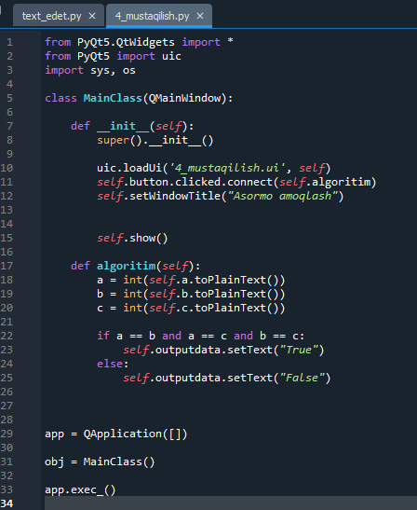

**Dastur natijasi:**

